Enterprise Systems (IT342)

Important Instructions:
- Read and understand the questions carefully.
- This is an individual work, so make sure it is your own.
- Search the book or other resources to have a better understanding of the questions.
- When you are asked to provide examples, make sure it is your own example and preferably from experience. Examples must not be identical to other students and have not been discussed in the classes.
- Use ‘Word Processor’ to answer the questions.NO word limit
- NO COPY/PASTE FROMTHE INTERNET WITHOUT CHANGING /OR THE SOLUTION MANUAL
- Plagiarism will result in ZERO mark.
From Chapter 7
Q1) Differentiate Inner Join and Outer Join with examples. Further, explain
Left Outer Join and Right Outer Join through examples.

From Chapter 7
Q2) Consider the given tables
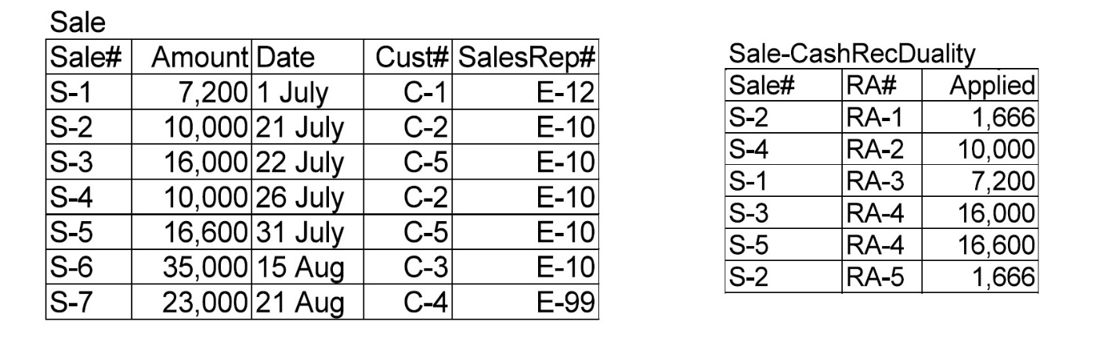
Write the result of the following query.
Select *
From Sale RightJoin [Sale-CashRecDuality]
Where [Sale.Sale#]=[Sale-CashRecDuality.Sale#];

From Chapter 8
Q3) Identify typical resources, internal agents, and external agents associated with each of the following business events:

a. Sales call or similar instigation event.
b. Sales order or similar mutual commitment event.
c. Sale, shipment and/or service engagement or other economic decrement event.
d. Cash receipt or other economic increment event.
e. Sale return or other economic decrement reversal event.

From Chapter 9
Q4) Horizon Books:
Horizon Books is a bookstore in downtown Madina Munawara. It carries an inventory of approximately 50,000 books. Customers come in and browse the shelves, select their books, and take them to one of three cashiers positioned in different parts of the store. One of the cashiers is situated at an information desk where customers can discover whether a particular book is in stock, place orders for books not currently available in the bookstore, and collect and pay for books previously ordered. The cashier at the information desk has a book database that is consulted for every query.
There are no credit sales. All customers pay for their purchases at the time of purchase.

Draw a diagram showing all cardinalities.

